Experiment 8.4
Determination and Plotting of Phase Velocity vs Relative Permittivity

Code File Name: Exp8_4_PhaseVelocity.m
Code
clc;
mu0 = 4*pi*1e-7;
epsilon0 = 8.854e-12;
er = linspace(1,5,100);
ur = 1;
v = 1./sqrt(mu0*epsilon0*er*ur);
plot(er,v,'LineWidth',2);
xlabel('Relative permittivity');
ylabel('Phase velocity (m/s)');
title('Phase Velocity vs Permittivity');
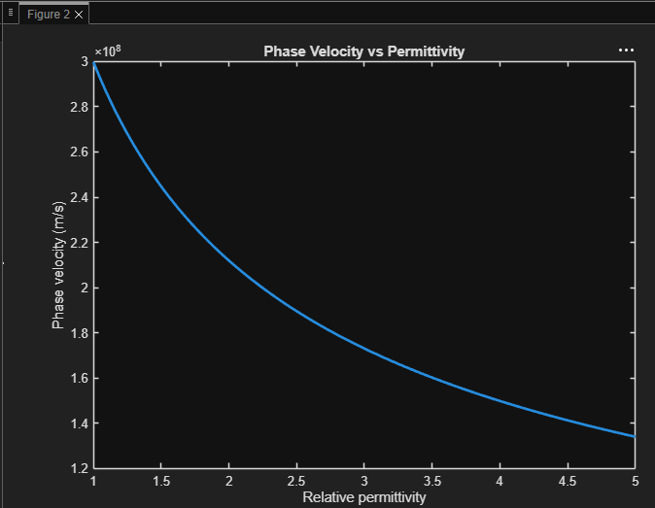
Output Graph

